**Task 3.1**

**SOFTWARE DEVELOPMENT PROPOSAL | Business Plan**

PREPARED FOR: Unisa ICT3715 department

PREPARED BY: Villemina Mashele 59449292

DATE: 01.08.2022

DEAR Unisa ICT3715 department,

RE: Enclosed Software Development Proposal

[Describe who you are and why you think you have the expertise to develop a software solution for him]

Regards

Villemina Mashele, 59449292

# Contents

1. Project Overview
2. Technology requirements (obstacles, hardware and software)
3. Deployment (installation, training, testing, backup and recovery, documentation)
4. Reporting (MIS)
5. Evidence

# Project Overview

The Online Exams Submission System provides an efficient way to manage exam papers and helps to assure exam paper security through electronic processes for the creation, transfer, and approval of test papers. The System allows academic staff to submit exam papers online for review by a co-examiner, who can then accept or reject the paper depending on whether adjustments are required. The System provides access to approved papers to assessment workers who produce the papers for the relevant examination session. The University portal and the Online Exams Submission System have direct contact. The objectives of online examination system or rather any other exam (purpose of online examination system) is to make sure that the student is thoroughly ware of the course curriculum and that the exam reflects the course content he/she has studied. Mapping your course content and exam questions is paramount to teaching and education. It’s what gives us the satisfaction that we’re on track and that what was intended to be taught and addressed in questions is done.

## Hardware

The software will run on any machine with a Web Browser

## Software

* XAMPP (Web Server)
  + Back-End: MySQL
  + Web Server: Apache SERVER.
* Visual Studio Code (Code Editor)
* Web Browser

## Obstacles

Design is the first step in the development phase for any techniques and principles for the purpose of defining a device, a process or system in sufficient detail to permit its physical realization. Once the software requirements have been analysed and specified the software design involves three technical activities - design, coding, implementation, and testing that are required to build and verify the software. Online examination system project. The design activities are of main importance in this phase, because in this activity, decisions ultimately affecting the success of the software implementation and its ease of maintenance are made. These decisions have the final bearing upon reliability and maintainability of the system. Design is the only way to accurately translate the customer’s requirements into finished software or a system. Use case diagrams model behaviour within a system and helps the developers understand of what the user require. The stick man represents what’s called an actor. Use case diagram can be useful for getting an overall view of the system and clarifying who can do and more importantly what they can’t do.

# Deployment

## Installation

* Extract the zip file inside the htdocs folder.
* Open phpMyAdmin and create a database called “ict3715_2022”.
* Import the file named “ict3715_2022.sql” inside the “db” folder.
* Open a browser and enter "http://localhost/projectfolder /"

## Training

Training materials

* [Online Exam Submission Training Manual v3.0](https://secure.ecu.edu.au/apps/OSEPS/staffonly/Training/Training-materials/Online-Exam-Submission-Training-Manual-v3.0.pdf) (PDF File, 2.2M)
* [Online Exams Submission System Process Flow](https://secure.ecu.edu.au/apps/OSEPS/staffonly/Training/Training-materials/Online-Exams-Submission-System-Process-Flow.pdf) (PDF File, 46K)
* [Online Exams Submission System Quick Reference Guide](https://secure.ecu.edu.au/apps/OSEPS/staffonly/Training/Training-materials/Online-Exams-Submission-System-Quick-Reference-Guide.pdf) (PDF File, 317K)

Training environment

* There is no training environment available for the Online Exam Submission System.

Training sessions

* Facilitated training for this web application may be available. Usually, staff requiring training in a particular application are directed to enrol in various sessions upon requesting access to the application itself.

## Testing

When you test PHP code locally, you can check your PHP scripts for both functionality and errors. Your best option is using XAMPP through your web browser to run your PHP scripts. If you prefer, there are online services available to find errors within your PHP code. If you choose to use XAMPP, follow the steps below.

**Step One**

Make certain XAMPP is installed. This is one of the most frequently used PHP testing environments for Mac and Windows computers. XAMPP can be downloaded and installed for free.

**Step Two**

If XAMPP is running, close it. Your htdocs folder can now be updated with no interference from the existing processes. If you are using a MAC, skip this step.

**Step Three**

Put your PHP files into your htdocs folder. If you are using Windows, open the folder labelled My PC. Double-click on the name of your hard drive, then your xampp folder and finally your htdocs folder. You need to move all required PHP files into your folder. If you are using a Mac, go to your XAMPP control panel and click the Volumes tab. Now click Mount, then Explorer and double click on your htdocs folder. Once again, move all required PHP files.

**Step Four**

Double click on your icon for XAMPP or open your XAMPP. Look for an orange background with a white X.

**Step Five**

Just to the right of your Apache heading, you will see the Apache web server. Click on Start. There is an indicator to your right that should turn green.

## Backup and recovery

The database is one of the main layers of any project we build. And if you’re not using an ORM to manage your databases, it becomes a bit difficult to manage databases. Especially while working on a project from multiple devices. For example, you can use GitHub to sync your file changes across multiple devices. But when it comes to the database, we have to go through multiple steps to get the job done. Such as manually exporting it from one device, moving the exported backup to another one, and importing it there. Now, what if you can create your own database backup and restore system? So, you can sync your database using GitHub and all other files! That would be awesome, right? Let’s drive then!.

**Backup Idea**

Okay, now, the idea is pretty simple. We will create a PHP file that we will use to complete the task. Like, before committing our changes to Github, we will simply visit the file and click a button called backup. This will create a backup of our database and save it in the current project directory. You just have to include this backup file in your [git commit](https://www.blogdesire.com/how-to-hide-commit-history-on-github/) before your subsequent push request!

– woa woa woa! But I don’t use GitHub. What about me?

Well, the principle is still the same for you. You can still include the file in your project, click the backup button, and move the backup file with your other files.

**Restore Idea**

Once you have the backup on the Github or somewhere else, you can pull or download your project on a different device and click the restore button on the same file. This will search for the backup file on our current directory. And if it finds one, It will restore the database backup file into the active database connection.

**Page Design**

Before developing the database backup and restore system, we first need to create an interface with just two buttons. One that says backup, and another one will say restore. The buttons will act accordingly if we click on them. Please create a PHP file and use the code below to get started, or you can create your own design.

**Database Backup and Restore Function**

Once you have the design ready, it’s time to make the buttons functional. So they can do their job perfectly. Place the code below at the very beginning of your PHP file that you just created in the last section of the article. Please change the database configuration before using the file in your projects.

## Documentation

* Assignment 1, 2, 3, 4
* Task 3.1
* Task 3.2
* Task 4

1. I start by opening my xampp software and running PHPMyAdmin using the localhost
2. Then extract the sql and csv file from the database and it adds it to the downloads folder
3. Then this get uploaded on a weekly basis to my GitHub accounts as well as to Google Drive for extra backup
4. GitHub being a source control software I can commit changes and go back to previous changes. Basically, it allows me to track changes made to the database file
5. 000webhost will also be used to upload the database from the local server to a cloud-based server.
6. This is done weekly to keep track of changes and make sure I have no database crashes.

# Reporting

### Create the Daily MIS report (5)

Reason

To provide the Exam Department with a list of all modules with focus on the module code, module description and date of exam this information helps to identify when a particular module is being written.

Query

$stmt = $conn->prepare("SELECT examsetup.ModuleCode, ModDesc, DateExam

FROM examsetup, moduleinfo

WHERE examsetup.ModuleCode = moduleinfo.ModCode

ORDER BY ModuleCode");

$stmt->execute();

$modules = $stmt->fetchAll();

Screen dumps

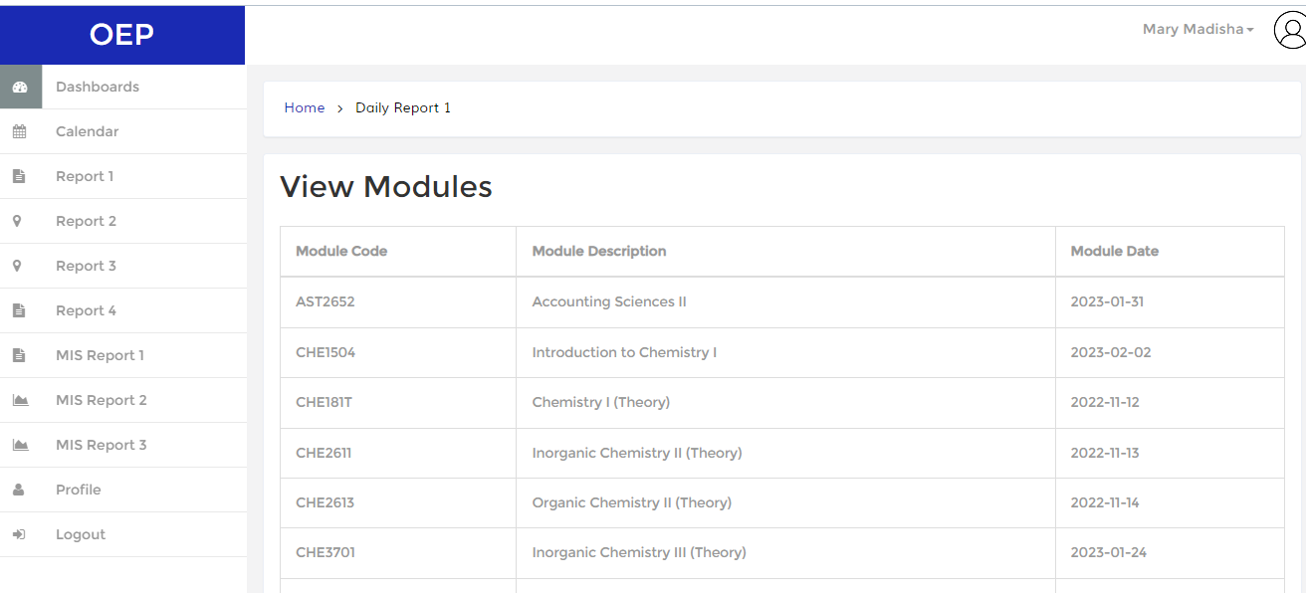

### Create the Weekly MIS report (5)

Reason

Display all lecturer’s info for the exam department and links the modules that they are leading.

Query

$stmt = $conn->prepare("SELECT Distinct(moduleleader.ModuleCode), ModDesc, name, email, DateExam

FROM moduleleader, moduleinfo, staffinfo, examsetup

WHERE moduleleader.ModuleCode = moduleinfo.ModCode

AND examsetup.ModuleCode = moduleinfo.ModCode

AND moduleleader.StaffNumber = staffinfo.StaffNumber

ORDER BY ModuleCode");

$stmt->execute();

$modules = $stmt->fetchAll();

Screen dumps

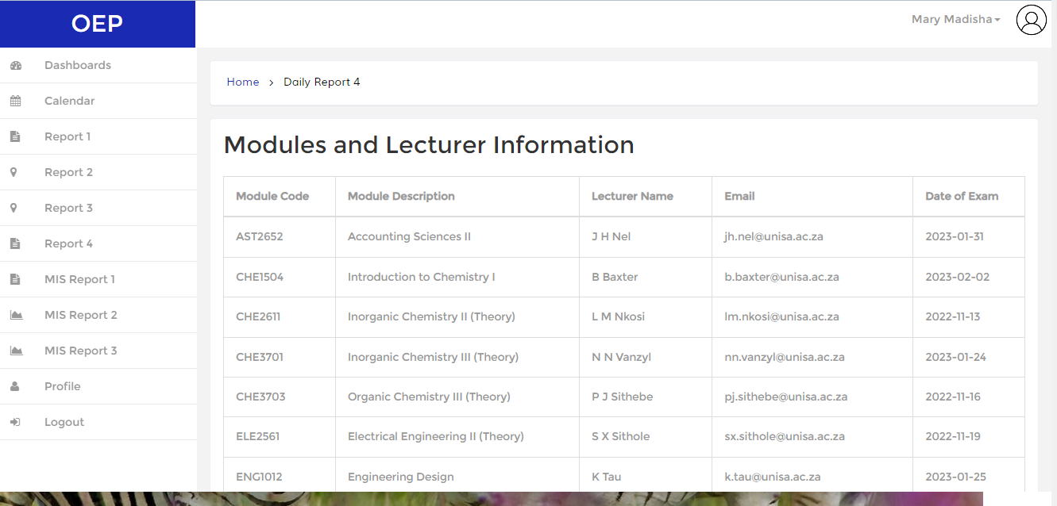

### Create one other MIS report (5)

Reason

3D Bar graph of modules with most registered student

Query

const dataSource = {

chart: {

caption: "Modules with Most registered students",

subcaption: "(With Group Values)",

numbersuffix: " Students",

yaxisname: "No of registered (students)",

theme: "candy",

plottooltext: "No of $label in $seriesName is <b>$dataValue</b>"

},

FusionCharts.ready(function() {

var myChart = new FusionCharts({

type: "errorbar2d",

renderAt: "chart-container",

width: "100%",

height: '700',

dataFormat: "json",

dataSource

}).render();

});

Screen dumps

### Create one other MIS report (5)

Reason

Bar graph with top module submissions

Query

//STEP 3 - Chart Configurations

const chartConfig = {

type: 'column2d',

renderAt: 'chart-container',

width: '100%',

height: '700',

dataFormat: 'json',

dataSource: {

// Chart Configuration

"chart": {

"caption": "Top Module Submissions",

"xAxisName": "Module",

"yAxisName": "File Uploads",

"numberSuffix": "",

"theme": "candy",

},

// Chart Data

"data": chartData

}

};

FusionCharts.ready(function(){

var fusioncharts = new FusionCharts(chartConfig);

fusioncharts.render();

});

Screen dumps

# Evidence

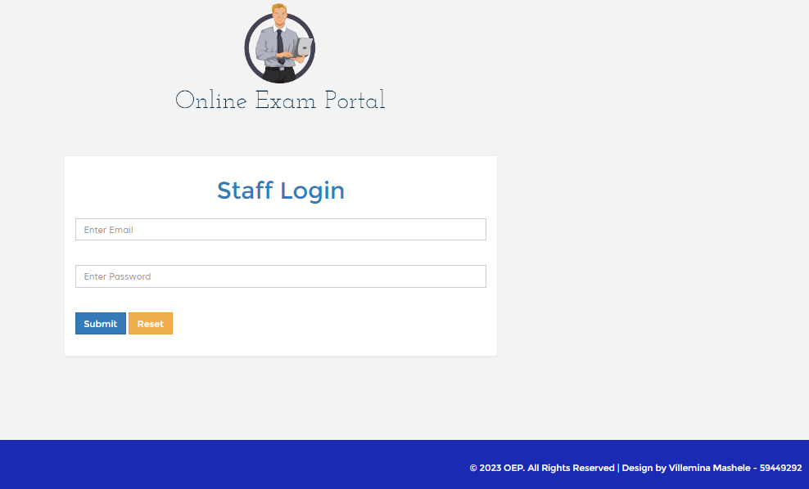

*Name & Surname: Villemina Mashele student number: 59449292*

*Signature:*  *Date: 01.08.2022*